**Assignment No:-70**

Name:-Suryawanshi Sangramsingh Sambhaji

Batch: - Delta - DCA (Java) 2024 Date:-4/9/2024

**Top interview questions**

1. Write a Java program to find the largest and smallest number in an array of integers.

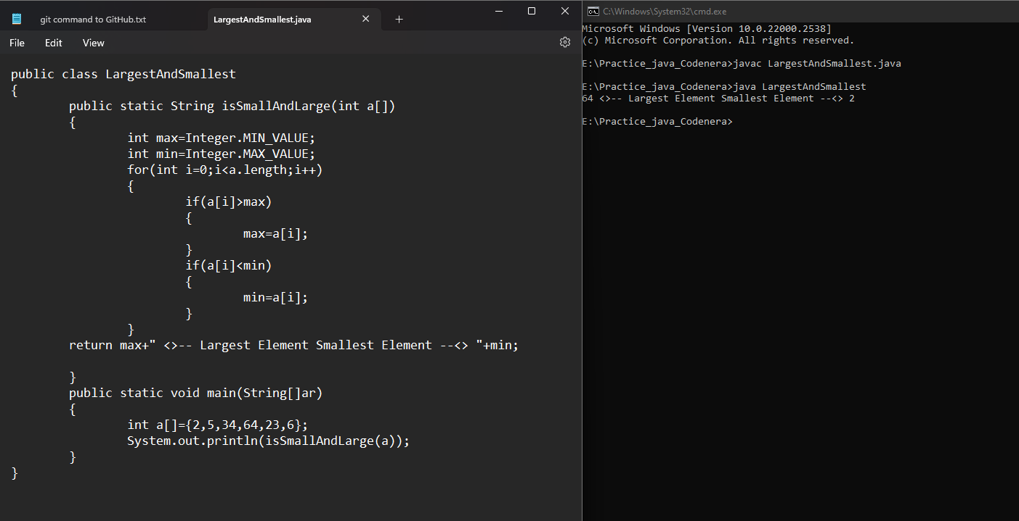

2. Write a Java program to sort an array of integers using the bubble sort algorithm.

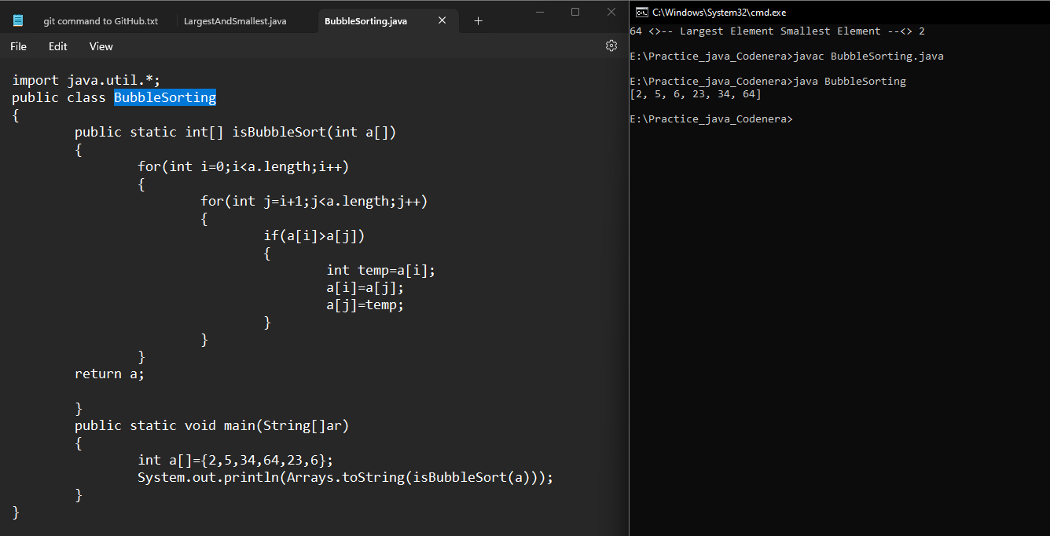

3. Write a Java program to find the second largest number in an array of integers.

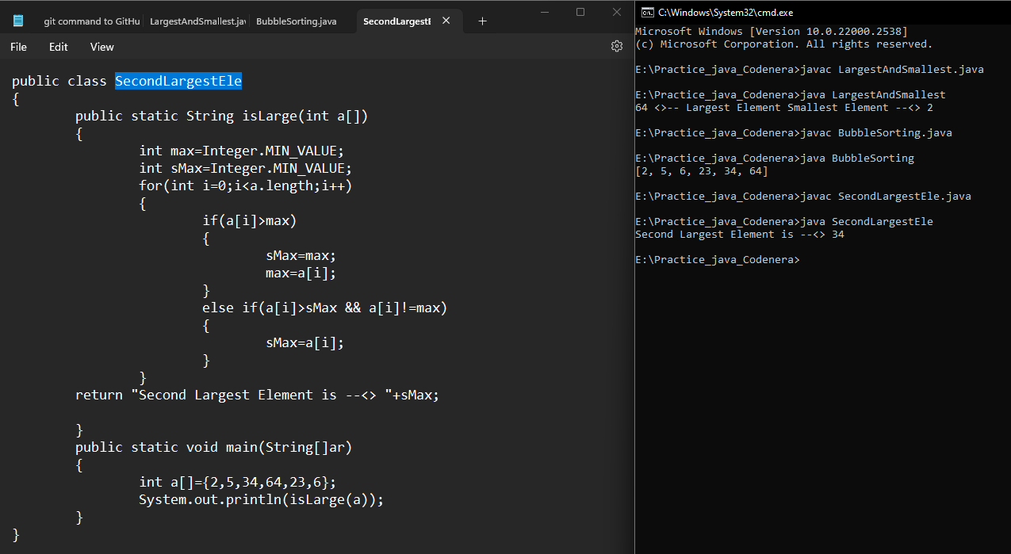

4. Write a Java program to reverse a string without using the built-in reverse() method.

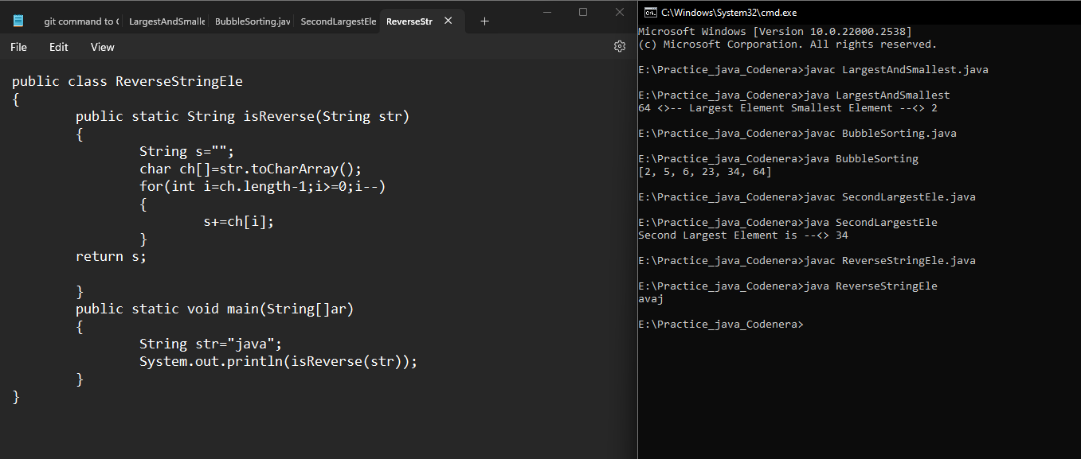

5. Write a Java program to check if a given number is a prime number.

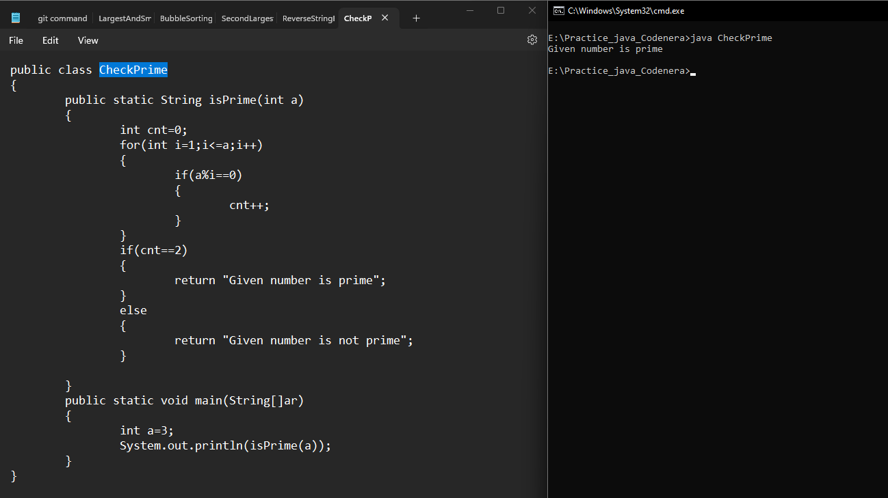

6. Write a Java program to find the Fibonacci sequence up to a given number.

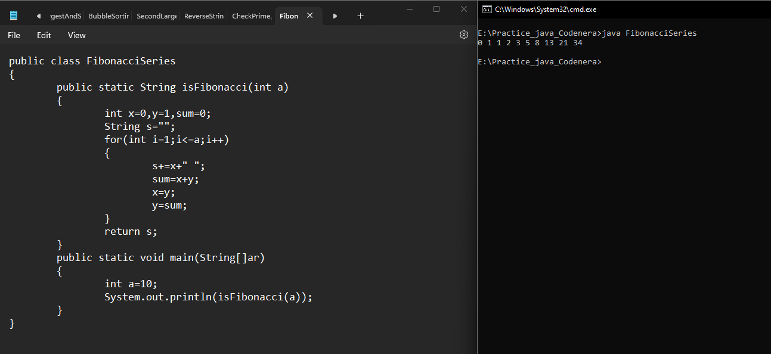

7. Write a Java program to calculate the factorial of a given number.

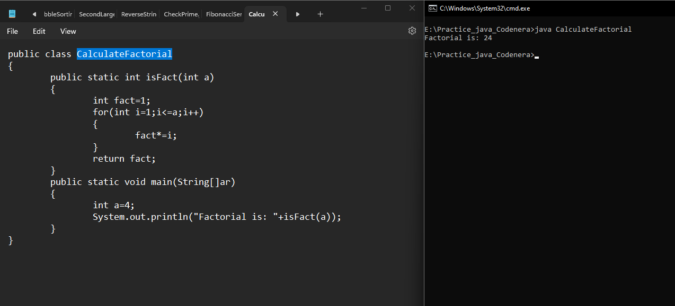

8. Write a Java program to check if a given string is a palindrome.

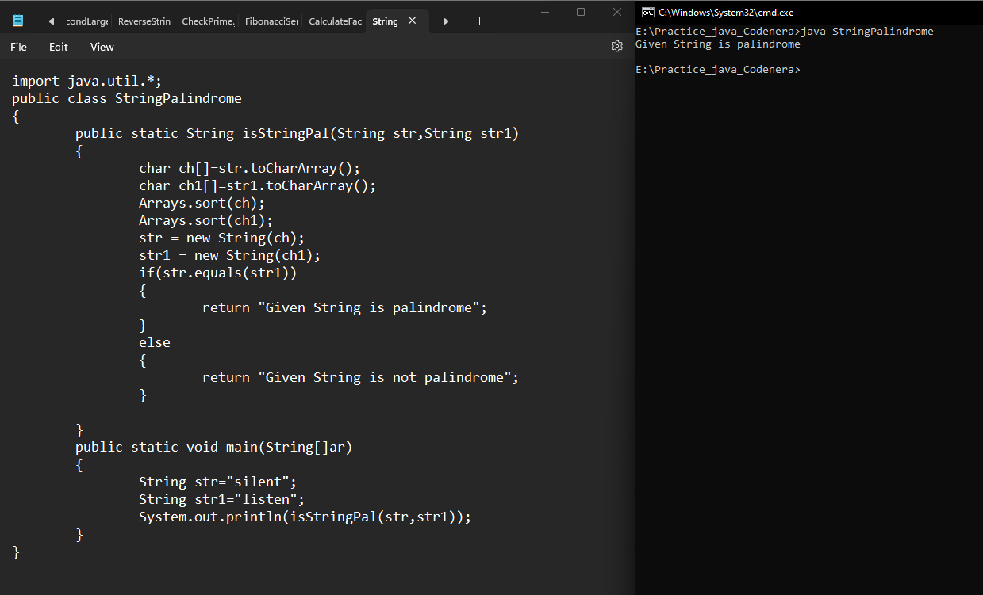

9. Write a Java program to find the common elements between two arrays of integers.

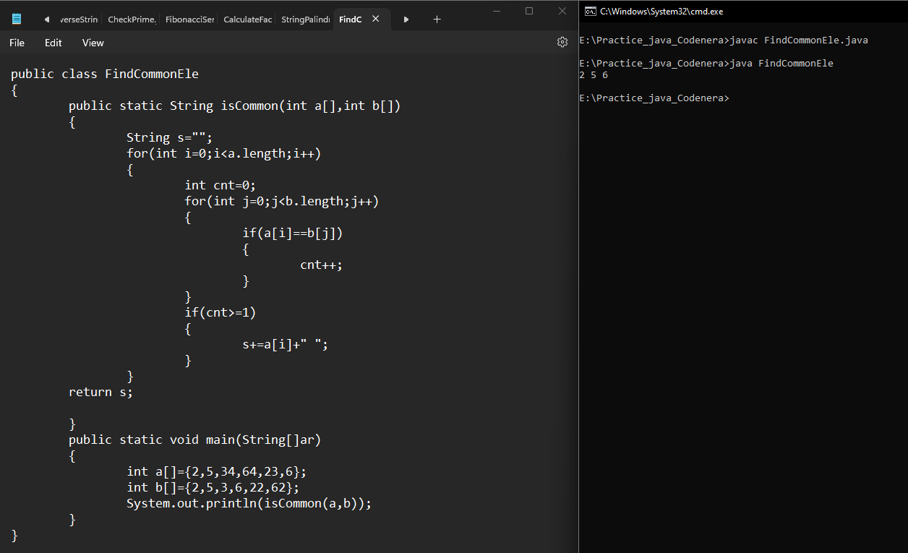

10. Write a Java program to find the intersection of two arrays of integers.



11. Write a Java program to merge two sorted arrays of integers into a single sorted array.

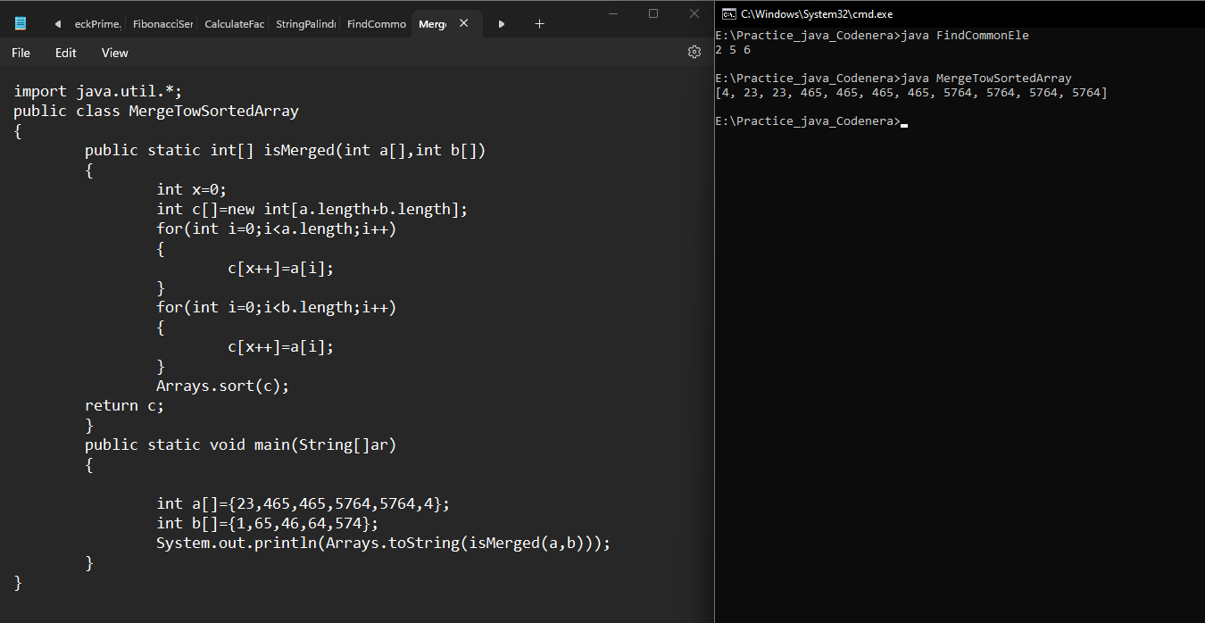

12. Write a Java program to count the number of occurrences of a given character in a

string.

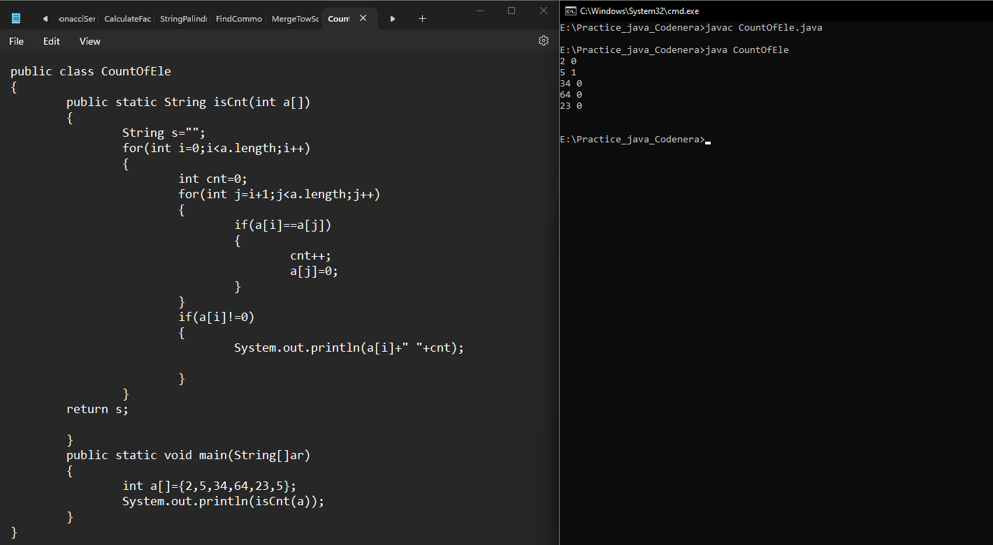

13. Write a Java program to find the missing number in an array of integers.

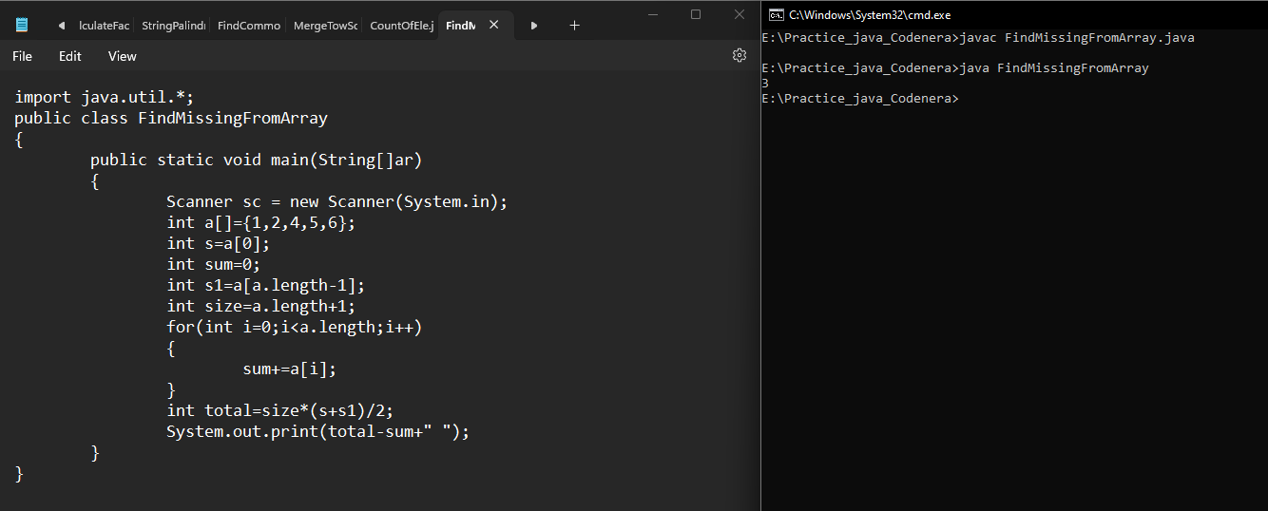

14. Write a Java program to find the sum of all elements in an array of integers.

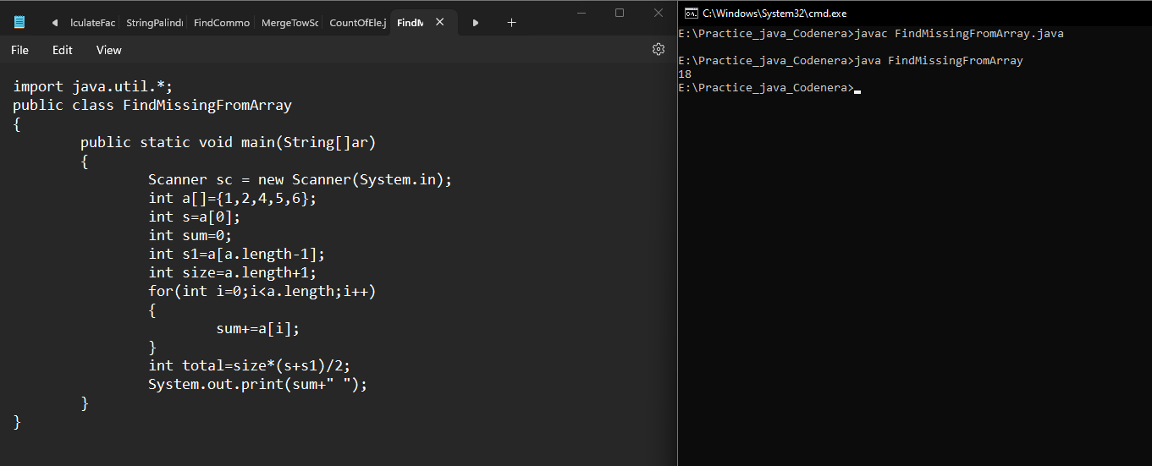

15. Write a Java program to find the average of all elements in an array of integers.

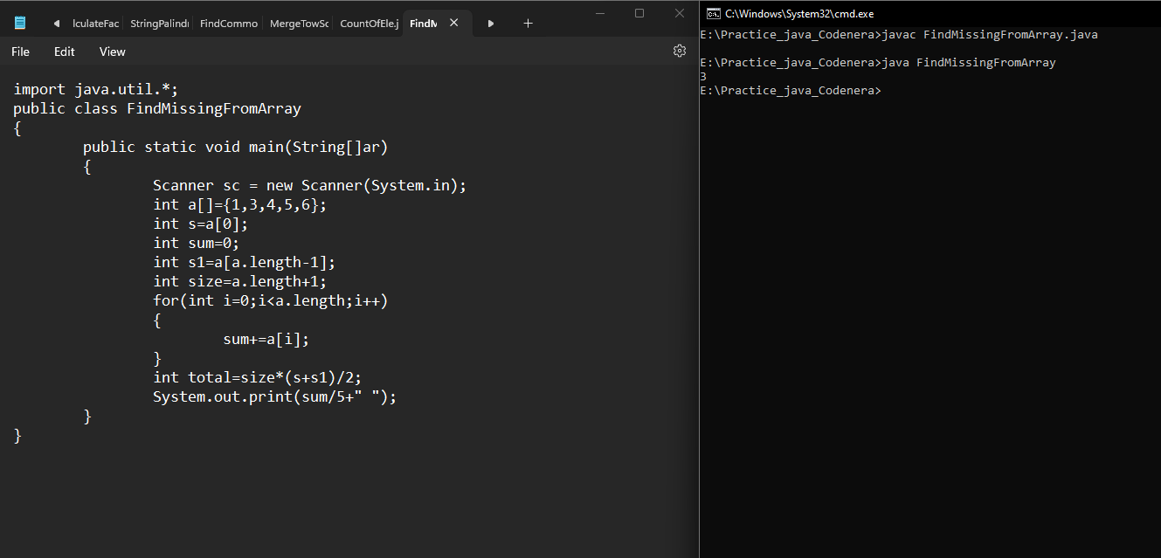

16. Write a Java program to find the sum of the digits of a given number.

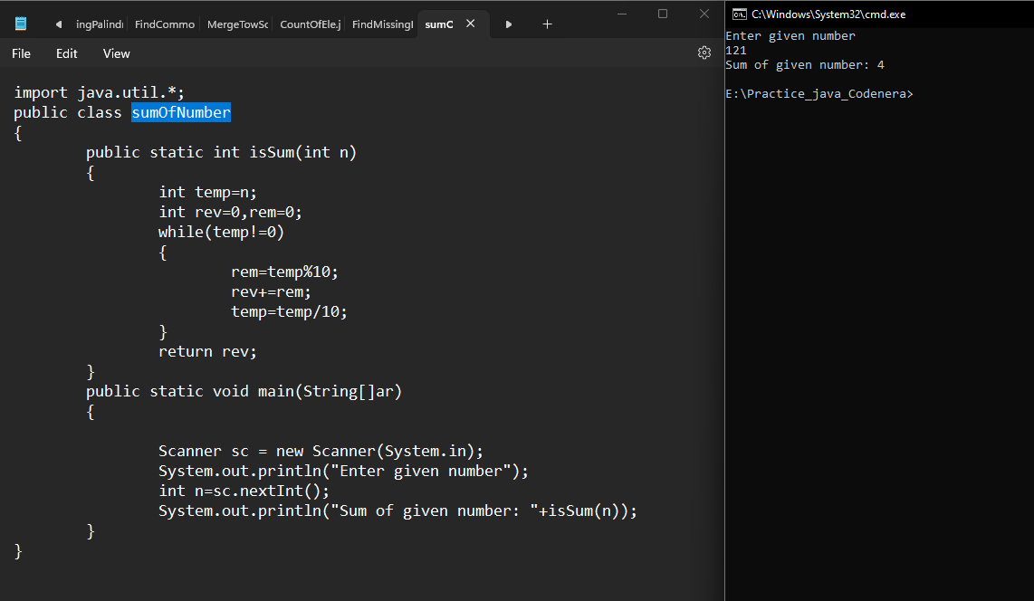

17. Write a Java program to check if a given number is an Armstrong number.

